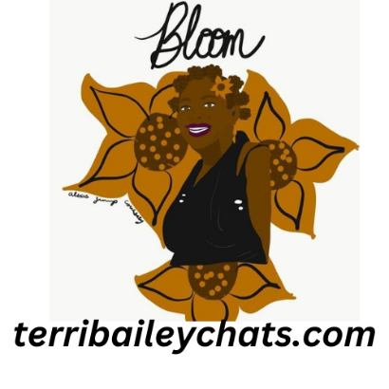
Terri Bailey Creative, Healing and Alternative Therapies Presents
Becoming Your Beautiful Authentic Self
A self-paced course designed to help you learn to live an authentic life!
Are you tired of pretending to be someone else?

Enroll Now!

And embark on your journey to a life that is free, joyful, powerful, and fully authentic!

Isn’t it time to stop being dominated by what other people think? To live YOUR life? To be your true, authentic self? To create a life that makes you happy, and does not cater to who someone else needs you to be? Author Alice Walker reminds us, “Don’t wait around for other people to be happy for you. Any happiness you get you’ve got to make yourself.”

Truly joyful, happy people are those who live wholehearted, authentic lives. They don’t wear masks, don’t pretend to be someone else, don’t let the opinions of others command them.

They are FREE to be the person they were made to be. Free to live an authentic life. Free to love themselves for who they are.

And yet so often, we feel driven and ruled by what OTHER people want. We want to be authentic…

...BUT WE DON’T KNOW HOW.

Brene Brown says, “Authenticity is a collection of choices that we have to make every day. It's about the choice to show up and be real. The choice to be honest. The choice to let our true selves be seen.”

Don’t you want that?
Imagine letting your TRUE self be seen, without fear, shame, pity, or guilt. Envision living that life without the need to apologize about being who you truly are inside.
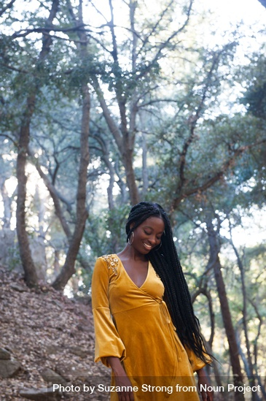
Ask yourself…
- Do I want to live an authentic life?
- Do I want to be free from the opinions of others?
- Do I always feel like I’m wearing a mask when I’m around others?
- Would my life be better if I was living an authentic, joyful, free life?

From the time we’re young, we’re told to be someone else.
Be smarter, like her. Be well-behaved, like him. Speak up, quiet down, study this, don’t go there, work harder, take it easy…Do...Do...DO!
It’s like living in a cage. We desperately want to break out.

To be free. To let our true selves, shine forth.

To discover our authentic selves and develop a healthy self-concept.

To stop living someone else’s life and start living OUR lives.

But we don’t know how.

We feel stuck. Caged. Imprisoned by fear of others.

But what if there were a solution? A way to break free, spread our wings, and experience the joy of the authentic life?

Now there is...

Introducing…
Becoming Your Beautiful Authentic Self
The step-by-step process for letting go of what others think and living as the REAL you...

This powerful course contains 49 lessons that lead you on a step-by-step journey to true, freeing authenticity. A journey of reflection, clarification, courage, self-acceptance, and love.

A journey to the TRUE you.

In the life-changing course, you’ll learn:

- How to shed the harmful expectations of others

- How to discover who YOU truly are (and NOT who others want you to be)

- How to UNLOCK your true passions

- How to build UNSHAKABLE self-esteem (that no one else can tear down…)

- How to let go of mistakes and learn to ACCEPT yourself (and finally move on)

- How to EMBRACE your individuality

- How to LOVE yourself (with all your strengths and weaknesses)

- How to FIND your life purpose and stop wandering from thing to thing

- How to show the world the REAL you without fear of what others think

- How to shape and create the JOYFUL life you’ve always wanted by living authentically
- And so much more!

This powerful journey could absolutely change your life.

In 20 years, you could look back on THIS as the time when you discovered true authenticity.

When you were set free.

When you stopped being what OTHERS wanted and became the person you were DESTINED to be.

THIS IS YOUR MOMENT.

Your fork in the road.

Your door to freedom.

The key to the cage has been given to you. You can either open the cage or throw it away.

It’s your choice. Will you be your authentic self or continue living as you have been?

You could try to learn all this on your own, but it would require hours upon hours of reading and research.

You wouldn’t have the guidance of an expert.

And you wouldn’t really know if you were making progress.

Or you could be taken by the hand and guided on this life changing journey.

Which will it be?

There are 6 modules with 49 total lessons. The modules are:

#1 - Knowing and Understanding Yourself

You’ll learn how to have a true understanding of who you are. You’ll find your personal identity, discover your deeply cherished values, and learn how to tap into your deepest passions. The journey to authenticity begins with understanding yourself, finding out who you want to be, and then charting the way forward.

#2 - Giving Your Self-Concept A Makeover

Once you understand yourself, you’ll give your self-concept a full makeover. You’ll discover the power of reevaluating your past, building and maintaining unshakable self-esteem, being proactive about increasing your satisfaction in life, and determining who you really want to be.

#3 - Learning to Accept Yourself For Who You Are

It’s a beautiful thing to accept yourself without judgment. In this powerful section, you’ll learn what it means to find true self-acceptance. You’ll come to terms with who you really are, let go of your past mistakes, and learn to forgive yourself. You’ll break free from those crippling self-doubts, eliminate your negative self-image, and learn the power of constructing a healthy self-image.

#4 - Learning to Love Yourself

Only when you learn to love yourself can you begin to love others. You’re going to finally learn how to embrace your individuality and stop desperately seeking the approval of others. You’ll learn how to avoid the fatal flaw of comparing yourself to others and the power of believing in yourself. Finally, you’ll learn how to love your body, emotional self, intellectual self, and spiritual self.

#5 - Determining Your Life Purpose

Through a series of revealing self-questions, you’ll unlock your true life purpose. You’ll also tap into the power of writing and meditation to help you find out what you should focus on for your life purpose. You’ll learn how to make your purpose an integral part of your life and you’ll discover the amazing benefits of finding your life purpose.

#6 - Living Authentically

In this final section, you’ll learn how to leverage everything you’ve learned so that you can live authentically. You’ll dare to be yourself, reveal your true personality, and find the courage to express your feelings. You’ll present yourself honestly, unlock the power of your inner voice, and develop the courage to create originality. To top it all off, you’ll create a compelling vision of the future for yourself.

Normally, live in-person workshops cost $500 to $1,000 for a 3-day workshop.

And my digital courses like this cost over $299.

But today, you’re going to get access to this entire life-changing program for ONLY $199.

You’ll get the entire Becoming Your Beautiful Authentic Self system:

- 49 lessons to lead you on the journey of authenticity ($299 value)
- 6 reflections to help you apply and implement what you’ve learned ($99 value)
- 6 debrief tests to empower you to remember the key points ($99 value)
- A thorough understanding of who you truly are (PRICELESS)
- Priority email support

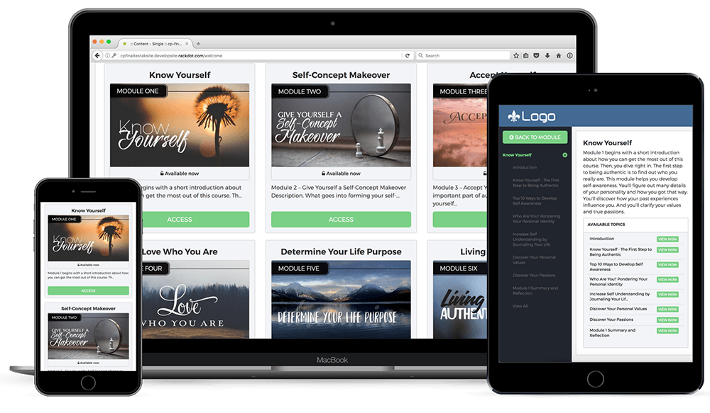

Finally, you’re going to...

- Create the authentic life you KNOW you were always meant to live!
- Become a more authentic friend, child, parent, or partner.
- FINALLY stop beating yourself up over past mistakes
- Learn to start LOVING who you are (and not be dragged by what others think of you)
- STOP pretending to be something you’re not...and be the REAL you!

Isn’t it time to embrace the life you deserve?

To become the authentic you?

The choice is yours.

Yes! I Want To Live Authentically! Sign me up!

Questions? Email: info@terribaileychats.com

About the Instructor
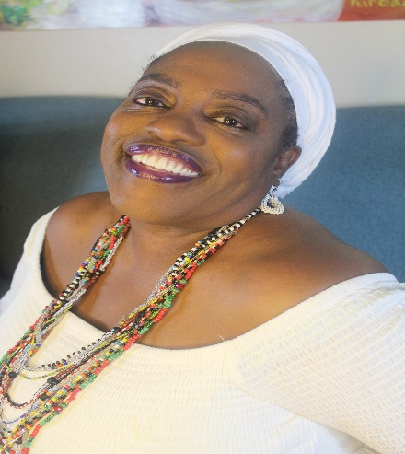
I am Terri L. Bailey. I am a graduate of Atlanta Job Corps Center, the great Bethune Cookman University (BS Elementary Education - Magna Cum Laude, ESOL Certification), Southern New Hampshire University (MA in English and Creative Writing) and the University of Florida (MA in Women, Gender and Sexuality Studies and Research). I am a survivor of sexual and domestic abuse, poverty, and religious trauma. During my healing journey, I became a certified Master Coach (Life, Body Image, and Empowerment) and EFT/TFT Practitioner. One of my true loves is writing. I write poetry and am a spoken word artist. I am an avid Afrofuturism fan who writes speculative fiction, and Black horror. I hope to publish a compilation of my short stories in the near future.

I am the founder of the Bailey Learning and Arts Collective (BLAAC - pronounced black) a nonprofit organization focused on building socially responsible communities and leaders through grassroots organizing, community education, and the arts. BLAAC’s first official program is The Queens Room Women’s Empowerment Group and virtual S.H.E. Shed. (SHE is Self-Care, Healing, and Empowerment). I have more than thirty years’ experience working in Black and Feminist women’s wellness and empowerment and decided it was way past time to get back to the business of helping women celebrate themselves and take control of their healing.

My most recent endeavor is Terri Bailey Creative, Healing and Alternative Therapies (Terri Bailey CHATs), a wholistic, comprehensive coaching and consultation service provider. The goal of the company is to help people become their most empowered and authentic selves. Services include life, creativity, and body image coaching, Emotional Freedom Technique (Tapping), self-care plan development, accountability services, as well as spiritual tools and consultations that offer insight and direction on your path to your higher purpose.

Frequently Asked Questions

Are there any requirements or prerequisites for this course?
No! It's open to anyone who wants to increase their satisfaction in life by learning to be authentic. Your success in this course depends on your willingness to take action. If you take the time to do the suggested self-reflections and exercises you will increase your confidence and begin to be unapologetically true to you.

What benefits will I receive from this course?
- You'll find out what it is to live authentically.
- You'll discover a lot about yourself and how you got that way.
- You'll learn how to accept yourself and love yourself just the way you are.
- Understand your own value and what you have to offer the world.
- You'll boost your self-confidence.
- You'll develop the courage to be yourself around others.
- You'll discover your passions and how to enjoy them in your daily life.
- You'll see how you can structure your life around what matters most to you.

Is there a particular audience that this course is geared toward?
Yes! This course is designed for those who want to be themselves around others, increase their self-esteem, build their confidence, and live their life according to what's important to them and not what's important to someone else.

Remember, for only $199 you're getting...
- A self-paced course with 6 modules and 49 lessons to lead you on the journey of authenticity [$299 value].
- Additional resources, reflections, and affirmations to help you apply and implement what you've learned [$99 value].
- Module quizzes to empower you to remember the key points [$49 value]
- A thorough understanding of who you truly are [ Priceless]!
- Priority e-mail support.
- A 14-day money back guarantee.

Will this actually work?
Yes, it absolutely will if you put in the work and make yourself and living your best life a priority!

.

14 Day Action Takers Guarantee! In fact, I’m willing to GUARANTEE it. If you act on the materials and don’t find improvement or growth on your journey to authenticity, I’ll refund your money. I only ask that you let us know how you feel we could have made the class better.

This 14-day action takers guarantee ENSURES that all the risk is on me. If these materials don’t empower you to unlock your authentic self, I’ll refund your money.

It’s all reward, NO RISK!

If you have any questions, please ask. I’m happy to help. I want you to live your authentic life. Click here to set up a free consult or email me at info@terribaileychats.com

YOUR INFORMATION IS SAFE

We hate SPAM and we promise to keep your information safe.

Secure Checkout via Square

Remember, I am in your corner!

Terri L. Bailey
Founder, Terri Bailey CHATs

